**Iowa Redistricting Proposal**

**Team SAAS**

**Simon Antaya & Austin Sawyer**

**5/2/2023**

**Executive Summary** The United States legislature divides the country into different districts to try to maintain and respect the power and representation of its citizens. To accurately reflect changes in the demographics of the U.S., we take a census to update information of the people every 10 years. With the information from the newest census, the state of Iowa has contracted us to present alternatives and updated maps of their districts. The state of Iowa has 4 congressional districts each of which have significant standards to uphold and improve upon moving forward. These standards are defined by both the federal and state governments and are established in legislation with methodology and expectations to approach these criteria. The main criteria we are trying to uphold is that all districts must have less than a one percent deviation between its most populous district and least populous district. The next is that we maintain the contiguity, being connected to the whole body, of each district so that representation of people is unified as much as feasibly possible. The third criteria we want to uphold is compactness. The federal government has not defined the expectation of how to achieve this “compactness” leaving the methodology up to the states to measure. The state of Iowa gives two options to measure compactness of its districts, length-width and perimeter length. The former method takes the quotient of the distance between the Easternmost point of the district and the Westernmost point by the distance between the Northernmost point and the Southernmost point. The perimeter length is a simpler calculation and much less arbitrary, we define the districts then take the perimeter length around each district then compare them to each other to achieve the smallest variation between them. We tested both of these alternatives, but found the latter to be more effective. When solving this problem we turned to methods of Operational Research to build an optimized mixed-integer program that would take in many variables and constraints then use them to build out our new districts while abiding by all the constraints placed by the legislative needs and requirements. So upon building these models and testing several alternatives we found that the model minimizes the perimeter length and operating within the bounds defined by legality and expectations we found a new map and districting plan that would satisfy all constraints and uphold to legal scrutiny.

**Introduction**

The United States government is divided into three branches: Executive, Judicial, and Legislative. These all have their own roles to play, and the citizens have their own involvement in the process. It is our duty to vote and elect our officials to these governing bodies, but with a population of 332 million spread about such a varying density and vast area we are challenged with making sure everyone is fairly represented in our government. Our federal government’s solution to this challenge is to divide the country into political divisions called districts, and these districts are meant to distribute power evenly without allowing biases to manipulate the equality we strive for. This is where this project begins, it is our goal to build a tool and use it to present a redistricting plan for the state of Iowa. Our proposal must not only satisfy our needs, but also maintain the laws and expectations of which they represent.

**Criteria**

Our criteria is fairly simple, we have to meet legislative requirements and then the other priority is to maintain the wishes for presentability of these districts in a logical manner. The federal government requires all districts in the state to have nearly identical populations to protect the representation and voting power of each individual. Our secondary responsibility is to the state’s legislation and dictation of the redistricting requirements, such as, contiguity and compactness and how they are measured is dictated by the state. The term contiguity isn’t very common outside of the redistricting committee, but it means that all counties in a district are sharing a border. Compactness is a bit more complicated and varies much more from political division to political division, Iowa’s legislation lists two potential ways they will measure compactness: Length-Width and Perimeter. Length-Width takes the greatest distance from its West to East then divides it by the distance from the Northernmost point to its southernmost point. Perimeter is much simpler and arguably less controversial by taking the distance around the perimeter and keeping the value as small as possible for all districts.

**Problem Statement**

The United States takes a census every 10 years to accurately represent changes in population and demographics within its borders. With the release of the most current data from the U.S. census we have been hired as consultants to assist in the redistricting process for the state of Iowa. It is our duty to ensure all of our proposals withstand legal scrutiny by maintaining all laws and constraints, but also do this in a transparent manner. This means it is our goal to accurately document our process and data used when calculating our results. Finally we want to present our proposal in an effective manner allowing it to be easily understood and removing ambiguity when it comes to what we are proposing and how we came to this conclusion.

**OR Model**

Our goal for this model is to minimize the deviation of all districts, and we have found an acceptable solution if this value is less than one percent between the largest and smallest populous districts. We start our model by importing the data of all counties of Iowa and their populations and assigning them to their own nodes. We then find the ideal population at the upper and lower limits of the imposed 1% deviation between the districts. We create two variables: x is a flag for true when county i is assigned to district j, otherwise it’s set to zero; the second variable y is a flag set to true when the edge from u to v is cut, otherwise it is set to 0, which defines the border of the congressional district. We define our objective function to minimize weighted cut edges which are set to the district perimeter lengths. Next we implement our necessary constraints to the model, so we begin by ensuring that each county *i* is assigned to at least one district *j.* We then apply the constraint that forces all districts to be within the upper and lower limits defined by the population. We also build a constraint using variable y to declare edge {U,V} cut if *u* is assigned to district *i* but *v* is not. Our next big constraint ensures that the districts are contiguous and we plan to use a Mixed Integer Program to ensure this. Using a max k-cut we need to assign a root to each district then regulate a flow from each root. Each county in a district then absorbs some of this flow and set a limit of each roots’ flow. After setting all of this up we then optimize our model.

Sets: nodes= {Counties of Iowa & their populations}

edges= {Set of all edges shared by county *i*}

Variables: xij= 1 when county *i* is a member of *j*, o.w. 0

yuv= 1 when edge u-v is cut, o.w. 0

rij= 1 when county *i* is the root of district *j*, o.w. 0

fuv = flow along edge u-v

Parameters: u= references county *i* along edge

j= references county *j* along edge

U= Upper limits of district population

L= Lower limit of district population

Obj: Min )

Constraints:

xuj- xvj <= yuv ⩝ j= range(k)

<= M* (1-yij) ⩝ i ∈ edges, j ∈ edges

**Code**

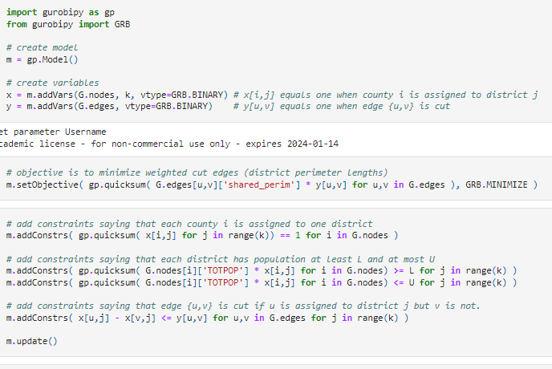

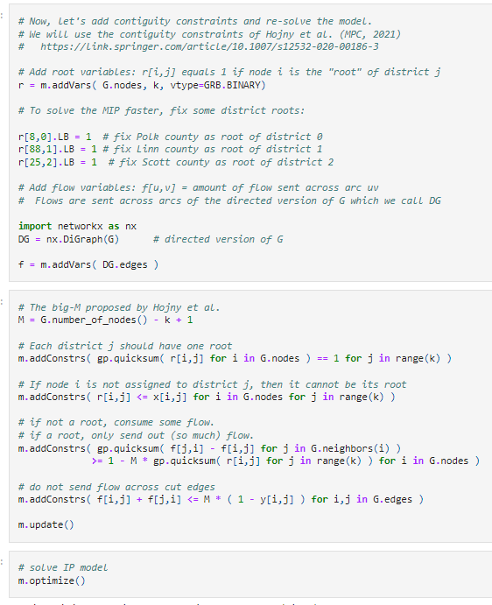

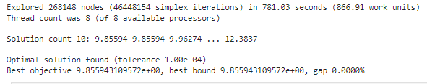

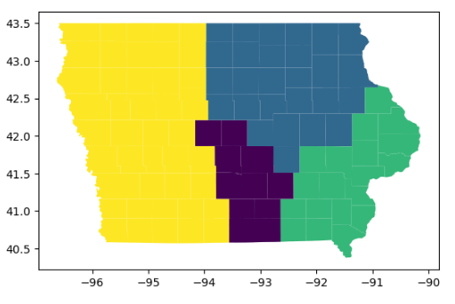

**Experiments**

This Model was solved on a 2016 HP Omen Gaming laptop, using an Intel I7-6700HQ @2.60 GHz and 16 GB of DDR4 2400MHz, instruction set [SSE2|AVX|AVX2]. Thread count: 4 physical cores, 8 logical processors, using up to 8 threads. The code was run on Jupyter Notebook version 6.5.4 and Gurobi version 10.0.0. It found an optimized solution in 781.03 seconds.

**Plans and Maps**

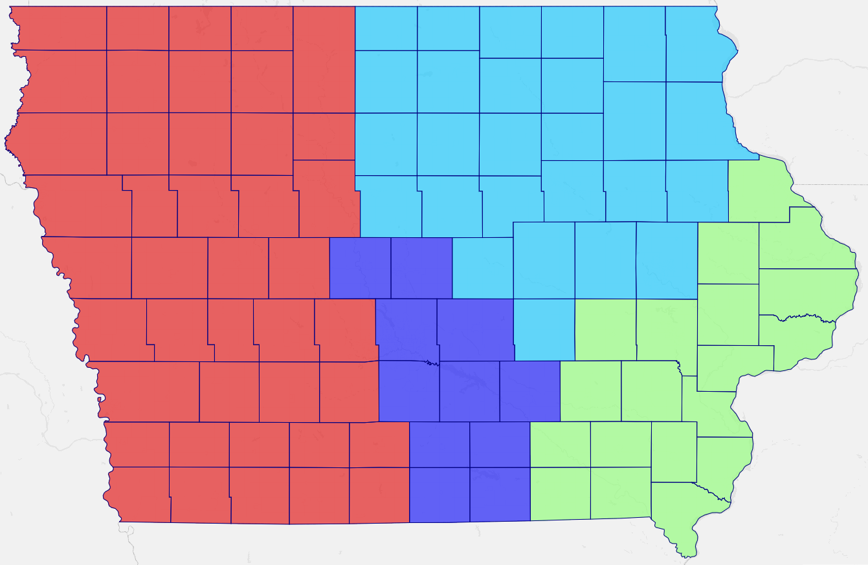

**Evaluation of Plan**

We did try solving this model with several different methods such as minimum cut edges with contiguity as well as minimum moment of inertia, but felt minimum perimeter with contiguity best fit our needs and expectations of the model. They all provided viable solutions, but this model gave results that satisfied all of our commitments to maintain legal scrutiny and in an organized manner. We know the model maintains total population deviation less than 1% and satisfies all other constraints listed above, and using this model prioritizes the compactness of our districts allowing for cleaner definitions of our districts. One limitation to this model is that we more than likely will never actually achieve a minimal population deviance because it is not our objective function, which would help limit even more balancing of the population we would like to see. Some other values we would like to represent that aren't included in this model are populations of demographics of racial and other traits that contribute to minority groups to protect.

**Conclusions**

We have found a viable model to redraw the districts of the state of Iowa, maintaining all legal constraints and expectations of the new districts. We had to make some adjustments to our initial model expectations and add parameters moving along to make comparisons between counties and edges. Our solution found an optimized map that minimizes the difference in perimeters of the counties while maintaining population boundaries for the imposed 1% deviation limits. If we were to dive deeper into this project we could incorporate more standards of representation of different minority groups to protect representation for these. Any further investigation of our code and experiments could be found on our GitHub repository.

District 1 has population 798498 and contains counties ['Story', 'Polk', 'Boone', 'Jasper', 'Monroe', 'Lucas', 'Warren', 'Wayne', 'Marion', 'Mahaska', 'Appanoose']

District 2 has population 797903 and contains counties ['Wright', 'Mitchell', 'Grundy', 'Winneshiek', 'Marshall', 'Delaware', 'Floyd', 'Hardin', 'Butler', 'Buchanan', 'Cerro Gordo', 'Tama', 'Hamilton', 'Franklin', 'Bremer', 'Allamakee', 'Winnebago', 'Howard', 'Worth', 'Black Hawk', 'Fayette', 'Chickasaw', 'Hancock', 'Poweshiek', 'Benton', 'Linn', 'Clayton']

District 3 has population 795577 and contains counties ['Keokuk', 'Davis', 'Jones', 'Des Moines', 'Scott', 'Lee', 'Iowa', 'Wapello', 'Henry', 'Louisa', 'Muscatine', 'Washington', 'Cedar', 'Jefferson', 'Clinton', 'Dubuque', 'Jackson', 'Van Buren', 'Johnson']

District 4 has population 798391 and contains counties ['Montgomery', 'Union', 'Sac', 'Audubon', 'Plymouth', 'Pottawattamie', 'Taylor', 'Page', 'Cherokee', 'Fremont', 'Emmet', 'Woodbury', 'Clay', 'Crawford', 'Osceola', 'Greene', 'Lyon', 'Adams', 'Monona', 'Humboldt', "O'Brien", 'Guthrie', 'Sioux', 'Ida', 'Cass', 'Decatur', 'Carroll', 'Pocahontas', 'Kossuth', 'Harrison', 'Webster', 'Madison', 'Palo Alto', 'Ringgold', 'Calhoun', 'Clarke', 'Adair', 'Shelby', 'Dickinson', 'Buena Vista', 'Mills', 'Dallas']

**References**

Github: <https://github.com/csi709/IEM4013-Districting-Iowa>.

Agency, Iowa Legislative Services. “Iowa Redistricting.” *Iowa Legislature - Iowa Redistricting*, Iowa Legislature, https://www.legis.iowa.gov/legislators/redistricting?&year=2011.

“State Redistricting Criteria.” *Summary Redistricting Criteria*, National Conference of State Legislatures, https://www.ncsl.org/redistricting-and-census/redistricting-criteria.

“Iowa's Congressional Districts.” *Wikipedia*, Wikimedia Foundation, 21 Feb. 2023, https://en.wikipedia.org/wiki/Iowa%27s_congressional_districts.

*Second Redistricting Plan - Iowa*. Legislative Services Agency, https://www.legis.iowa.gov/docs/publications/REDST/2021/Updates/Plan2_Report.pdf.

*Redistricting Standards*. Iowa Legislature, https://www.legis.iowa.gov/docs/code/2016/42.4.pdf.

“Iowa.” *Districtr*, https://districtr.org/iowa.

“Dra 2020.” *Daves Redistricting*, https://davesredistricting.org/maps#state::IA.